**Collections Working with JavaScript Arrays**

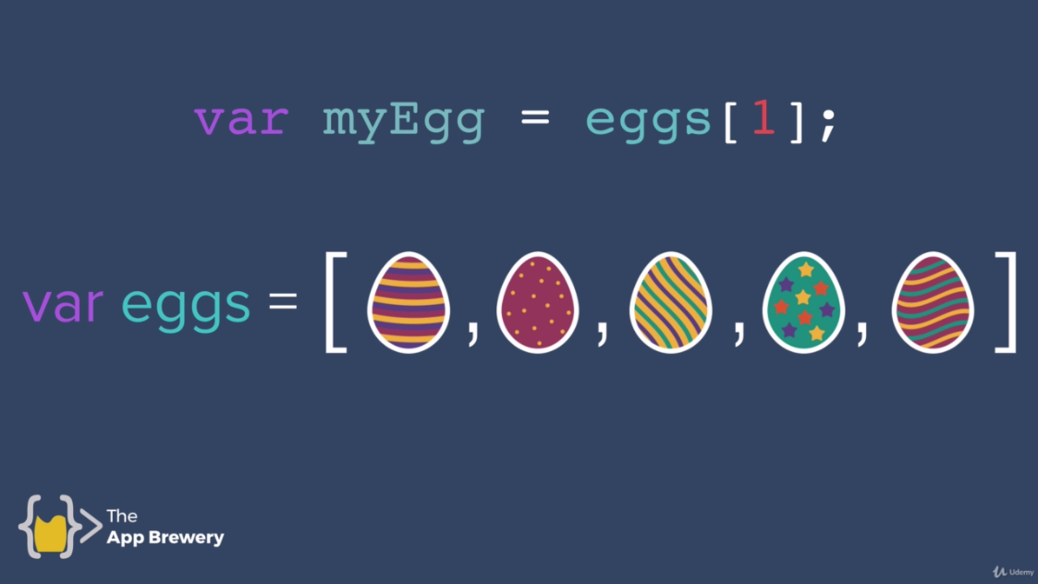



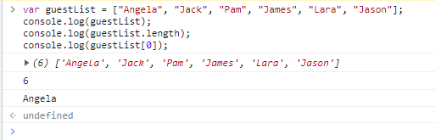

var guestList = ["Angela", "Jack", "Pam", "James", "Lara", "Jason"];

console.log(guestList);

console.log(guestList.length);

console.log(guestList[0]);

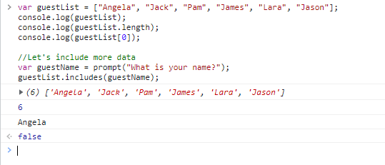

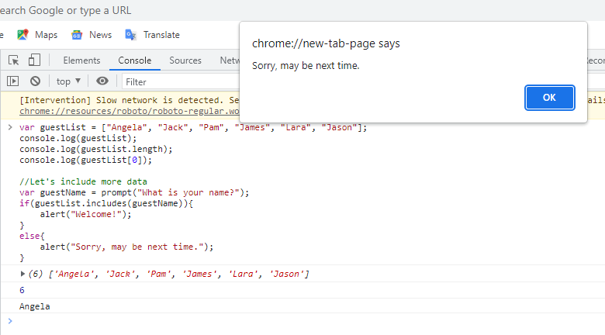

var guestList = ["Angela", "Jack", "Pam", "James", "Lara", "Jason"];

console.log(guestList);

console.log(guestList.length);

console.log(guestList[0]);

//Let's include more data

var guestName = prompt("What is your name?");

if(guestList.includes(guestName)){

alert("Welcome!");

}

else{

alert("Sorry, may be next time.");

}